Standardization of Basic Solutions and Titration

Name
Institution of Affiliation
Professor
Date

Standardization of Basic Solutions and Titration
Part A. Making the NaOH solution
Prelab and Calculations: (Based on completeness and correctness)
- (Manipulation) Calculate the amount of solute required to produce 100 mL of 0.3 M NaOH solution.
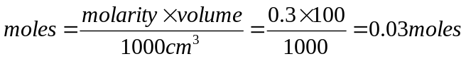
of NaOH
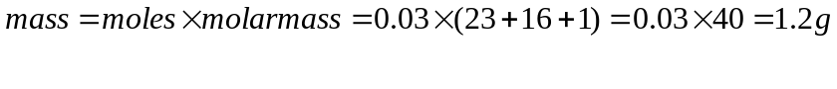of NaOH
- (Representation) Prepare your chemical table including the mass of solute and approximate volume of solvent. You can use this general template, replacing each chemical with its name and formula.
Chemical Name | Chemical Formula | Molar Mass  (g/mol) | Used amount | Hazards | PPE
Sodium Hydroxide | NaOH | 40.0 | 1.2g | Corrosive, causes irritation on skin and eyes. | Gloves, safety glasses, face mask.
Hydrogen Hydroxide | H₂O | 18.0 | 100cm³ | - | Gloves.

- (Analysis) Identify the equipment (type AND size) needed for the experiment and include the name and image of each.
Medium size electronic balance
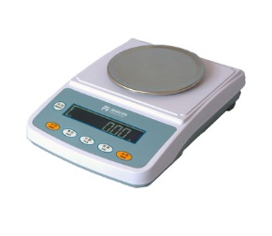
Spatula
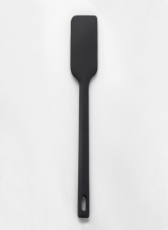
250ml Measuring cylinder
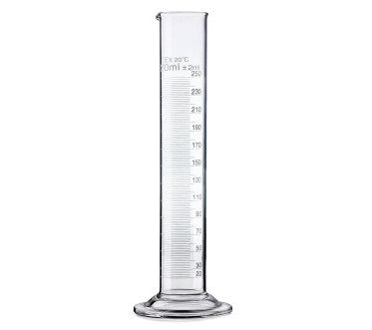
100 ml volumetric flask
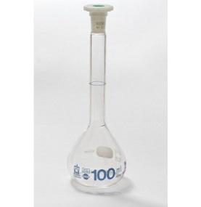
Discussion: (Evaluated based on the discussion grading rubric)
- (Analysis) Provide a detailed description for preparing 100 mL of 0.3 M NaOH solution. Make sure to describe what equipment you would use, how it is used and which characteristic of the equipment make it suitable for this purpose.
Procedure
i. Using an electronic balance, accurately weigh 1.2g of sodium hydroxide pellets into a 100ml plastic beaker. Ensure to use a spatula to scoop the solid from the container.
ii. Measure 20ml of distilled water using a measuring cylinder and add to the solid in the beaker. Swirl to dissolve the sodium hydroxide.
iii. Transfer the mixture into 100ml volumetric flask and rinse the beaker with distilled water.
iv. Top up to the mark with distilled water from a wash bottle and label the solution, 0.3M NaOH.
- (Assumptions) Consider the properties of NaOH. Identify factors that can, and likely will influence the molarity of your NaOH solution. Comment of the magnitude of the change and whether the molarity will increase or decrease as a result.
NaOH is highly soluble in water to give OH⁻_{(aq)} increasing its concentration in solution.
- (Assumptions) NaOH is a strong base and is often used in chemistry laboratory experiments. What other applications does NaOH have? Do you have any NaOH in your house? If yes, what is the concentration of your solution?
NaOH is used in:
Manufacture of toothpaste
Manufacture of soap
Manufacture of paper and plastic
Standardizing Basic Solutions and Titration - Part B
Part B. Standardizing the NaOH solution
Prelab and Calculations: (Based on completeness and correctness)
- (Representation) Write a balanced chemical equation for the reaction of aqueous NaOH and KHP.
NaOH_{(aq)} + KHC₈H₄O_{4(aq)} KNaC₈H₄O_{4(aq)} + H₂O_{(l)}
- (Manipulation) Calculate the amount of KHP required to consume approximately 25 mL of 0.3 M NaOH solution. Round up to the nearest tenth of a gram. (x.x g)
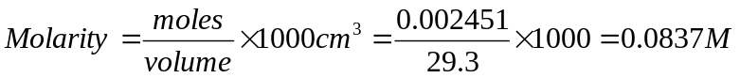of KHP
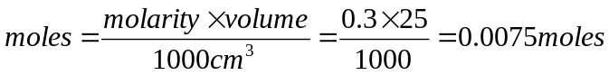of NaOH
Moles of KPH = moles of NaOH = 0.0075 moles
Mass of KPH = (nearest tenth)
- (Representation) Prepare your chemical table including the mass of all solids and the volume of all solutions. You can use this general template, replacing each chemical with its name and formula.
Chemical Name | Chemical Formula | Molar Mass  (g/mol) | Used amount | Hazards | PPE
Sodium Hydroxide | NaOH | 40.0 | 0.3g | Corrosive, causes irritation on skin and eyes | Gloves, safety glasses, face mask.
Potassium hydrogen phthalate | KHC₈H₄O₄ | 204.22 | 1.5g | Corrosive, causes irritation on skin and eyes | Gloves, safety glasses, face mask.

- (Analysis) Identify the equipment (type AND size) needed for the experiment and include the name and image of each.
Medium size electronic balance
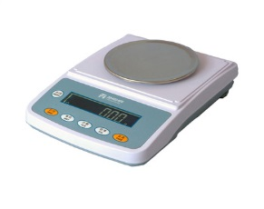
Spatula
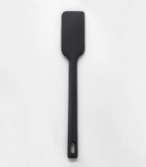
250ml Measuring cylinder
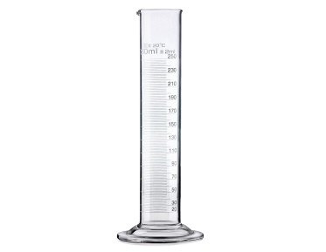
100 ml volumetric flask
Discussion: (Evaluated based on the discussion grading rubric)
- (Interpretation) Describe the meaning of the molecular equation between the NaOH and KHP on the microscopic (molecular level) and macroscopic (visible) scales, and by mass.
NaOH is an alkali with a molecular mass of 40.0g. It is an ionic compound with Na⁺ and OH⁻. KPH is an acid salt with a molecular mass of 204.
- (Analysis) Provide a detailed description for standardizing the 0.3 M NaOH solution with the calculated amount of KHP. Make sure to describe what equipment you would use, how it is used and which characteristics of the equipment make them suitable for this purpose.
Put 0.3M of NaOH solution in a 50mL burette. Using a weighing balance, measure 1.5g of KPH salt into a conical flask. Add 29.3mL of distilled water and shake well to dissolve the entire solid. Add 2 drops of phenolphthalein indicator and shake. Titrate the solution against NaOH solution from the burette until a permanent pink color is observed. Record the titer volume in a table. Repeat the above procedure two more times to determine an accurate titer value.
- (Assumptions) Consider the properties of NaOH. Identify reasons why it needs to be standardized before being used in a measurement.
Sodium hydroxide is a deliquescent salt hence absorbs water from the atmosphere and forms a solution. For this reason, sodium hydroxide should be standardized to help determine its accurate concentration of the solution used in reactions.
- (Assumptions) Consider the properties of KHP. Identify any properties that make KHP a good choice for the standardizing of a basic solution.
It is highly soluble in water
It is stable
It does not absorb water from the atmosphere
- (Analysis) This experiment requires an acid-base indicator. Describe how an acid-base indicator works and why it is needed for this experiment.
An indicator exhibits a color change in a base and a different color change in an acid. It is important in this reaction as it help determine the end-point of the titration.
Standardizing Basic Solutions and Titration - Part C
Part C. Titrating HCl/Sprite with the standardized NaOH solution
Prelab and Calculations: (Based on completeness and correctness)

- (Representation) Write a balanced chemical equation for the reaction of aqueous NaOH with aqueous HCl.
NaOH_{(aq)} + HCl_{(aq)} NaCl_{(aq)} + H₂O_{(l)}
- (Representation) Derive the complete and net ionic equations for the reaction of aqueous NaOH and HCl.
OH⁻_{(aq) +} H⁺_{(aq)} H₂O_{(l)}
- (Manipulation) Assume that the concentration of the HCl solution is 0.25 M. Calculate the maximum volume of the HCl solution you would use to consume 30 mL of the 0.3 M NaOH solution. Round up to the nearest tenth of a milliliter. (xx.x mL)
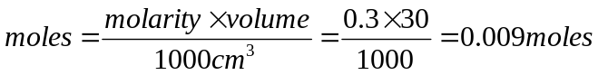of NaOH
Moles of HCl = moles of NaOH = 0.009 moles
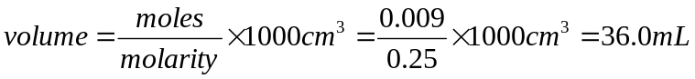of HCl
- (Representation) Prepare your chemical table including the volume of all solutions. You can use this general template, replacing each chemical with its name and formula.
Chemical Name | Chemical Formula | Molar Mass  (g/mol) | Used amount | Hazards | PPE
Sodium hydroxide | NaOH | 40.0 | 0.36g | Corrosive, causes irritation on skin and eyes | Gloves, safety glasses, face mask.
Hydrochloric acid | HCl | 36.5 | 36.0 mL | Corrosive, causes irritation on skin and eyes | Gloves, safety glasses, face mask.

- (Analysis) Identify the equipment (type AND size) needed for the experiment and include the name and image of each.
Medium size electronic balance
Spatula
250ml Measuring cylinder
100 ml volumetric flask
Discussion: (Evaluated based on the discussion grading rubric)
- (Interpretation) Describe the meaning of the molecular equation between the NaOH and HCl solutions on the microscopic and macroscopic scales.
From the chemical equation between NaOH and HCl, 1 mole of a solution of NaOH reacts with 1 mole of HCl.
- (Analysis) Provide a detailed description for titrating the calculated volume of HCl solution with the 0.3 M NaOH solution. Make sure to describe what equipment you would use, how it is used and which characteristics of the equipment make them suitable for this purpose.
Put 0.3M of NaOH solution in a 50mL burette. Using a measuring cylinder, measure 36.0mL of 0.25M HCl solution into a conical flask. Add 2 drops of phenolphthalein indicator and shake. Titrate the solution against NaOH solution from the burette until a permanent pink color is observed. Record the titer volume in a table. Repeat the above procedure two more times to determine an accurate titer value. Fill the table and find the final burette readings hence the average volume of NaOH used in the titration.
- (Assumptions) Consider the properties of HCl solutions. Identify reasons why it needs to be titrated to determine its actual concentration. HCl is a strong acid hence easily dissociates to form H⁺ thus increasing its concentration in solution.
- (Analysis) The HCl solution and the Sprite were both titrated with the standardized NaOH solution. Identify at least one aspect in which HCl and Sprite are similar and at least one aspect in which HCl an Sprite are different.
Both sprite and HCl can react with bases such as NaOH to form salt and water.
The reaction between HCl and bases is faster as compared to thereaction between sprite and bases since HCl is a strong acid hence undergoes complete ionization to give H⁺
- (Analysis) This experiment was demonstrated with phenolphthalein and with universal indicator. Describe the difference between the two indicators.
Phenolphthalein indicator only shows the end-point of the titration whereas universal indicator apart from showing the end-point also gives the pH to determine the nature of the solution formed after titration.
- (Assumptions) Are there any other methods that can be used if an indicator is not available? Describe one.
It is difficult to carry out an acid-base reaction in the absence of an indicator. An indicator is used to determine the point of neutralization of the reaction.

